MDM4-S primer design and intron retention primer design

**MDM4 5-6b-7 primers (alternate MDM4-S isoform)**

5-6b-7 sequence:

CCCTCTCTATGATATGCTAAGAAAGAATCTTGTCACTTTAGCCACTGCTACTACAG**GATCACAGTATGGATATTCCAAGTCAAGACCAACTGAAG**CAAAGTGCAGAGGAAAGTTCCACTTCCAGAAAAAGAACTACAGAAGACGATATCCCCACACTGCCTACCTCAGAGCATAAATGCATACATTCTAGAGAAG

Forcing forward primer to span exon 5-6b junction evenly

**MDM4 5-6b-7 F1 (pair with R1 and R2)**

CTGCTACTACAG**GATCACAGTATG**

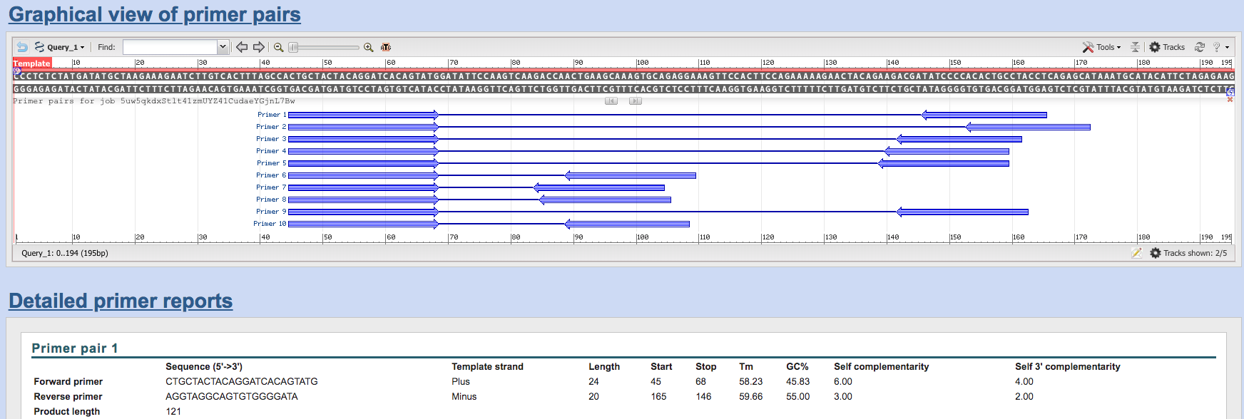

**MDM4 5-6b-7 F2 (pairs with exon 7 R1 and R2)**

Spans 16 bp on the 5’ end and 6 bp on 3’ end

GCCACTGCTACTACAG**GATCAC**

**MDM4 exon 7 R1**

AGGTAGGCAGTGTGGGGATA

Reverse primer #2



**MDM4 exon 7 R2**

TCCTCTGCACTTTGCTTCAGT

**For R1 pairing info**



**For R2 pairing info**



**Intron i[5-6]-6-7 primer design**

GTTTTACTTGCTATCCAG**ATGCTGCTCAGACTCTCGCTCTCGCACAGGATCACAGTATGGATATTCCAAGTCAAGACCAACTGAAG**CAAAGTGCAGAGGAAAGTTCCACTTCCAGAAAAAGAACTACAGAAGACGATATCCCCACACTGCCTACCTCAGAGCATAAATGCATACATTCTAGAGAAG

**Intron i[5-6]-6-7 F1**

CTTGCTATCCAG**ATGCTGCTCAGA**

**For R1 pairing info for i[5-6]**

AGGTAGGCAGTGTGGGGATA



**For R2 pairing info for i[5-6]**



**Bartel et al primer pairing info**

<http://onlinelibrary.wiley.com/doi/10.1002/ijc.21206/full>

the PCR consisted of 50 cycles with 30 sec of denaturation at 95°C, 30 sec of primer annealing at 58°C and synthesis at 72°C for 30 sec.

**Bartel MDM4-S qPCR F**

CAGCAGGTGCGCAAGGTGAA

**Bartel MDM4-S qPCR R**

GCACTTTGCTGTAGTAGCAGTG